**Holmer Green Football Club Pre-Season Tournament 2024 Round Up**

Facebook event advertising the tournament to support the team and fundraising for the 3g pitch.

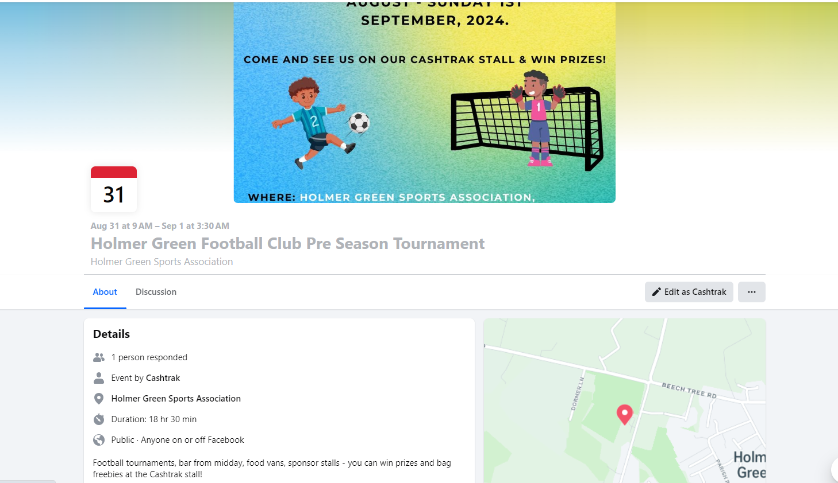

Here is Carol ready for action at the stall

Fantastic team photo

